FOR IMMEDIATE RELEASE

London Residents Can Slash Energy Bills by Up to 90% — 70% Already On Board

London, UK — 14 October 2025 — Over 70% of residents approached in Haringey and Islington have already provided emails to join Future Now Empowered’s Community Energy Clusters, with 86% expressing interest and 80% supporting the shared finance model. Together, these clusters could cut household energy bills by up to 90%.
Future Now Empowered (FNE), a social-enterprise spin-out from Future Now Partners, is pioneering 200–500 home Community Energy Clusters that combine solar panels, shared batteries, and smart energy management. The result: ultra-low-cost, reliable electricity — owned by residents, schools, businesses and the wider community — creating a self-sustaining cycle of local energy independence.
“Paying £1,000 a month for bills, we really want change,” said Chanica, a resident from Islington.
“Finally a door-to-door project that makes you feel positive,” added John, Haringey.
Unlike other energy projects, FNE combines local engagement, resident financial ownership, and a scalable model to help other communities launch their own clusters — while also supporting our National Grid. Shared batteries not only provide cheap, reliable power locally, but also strengthen our grid, smoothing voltage spikes and enabling broader renewable integration for everyone.
How it works:
- Communities start together, install infrastructure, and see bills drop immediately.
- Contributions go into a shared pot, funding the next cluster — creating a self-sustaining movement.
- Once clusters are paid off, energy stays near zero cost, and social and economic impact grows.

“FNE isn’t just about cheaper energy — it’s about ownership, fairness, and resilience. Together, every one of us becomes a shareholder in the future, and it starts now,” said Founder DeQuincy Prescott.
Join the movement today — help your community and our grid. Residents, businesses, funders, journalists, and green-tech partners can sign up at FNEmpowered.com or email fne@fnpnow.com.

Notes to Editors
Additional Resident Quotes:
- “Looking forward to it happening! Will put on local WhatsApp groups.” — Helena, Islington
- “Are you going to change the world?” — Alex, Haringey
- “Great for future generations.” — Margarita, Islington
- “You’re doing a good thing. Sign me up. I want a job with the company.” — Craig, Haringey
- “How would houses be paying for a pub which has a massive bill compared to a local house?” — Local Publican, Islington
Project Overview:
- FNE integrates solar PV, shared battery storage, and smart energy management in clusters of 200–500 homes, creating community-owned green infrastructure that is fair, predictable, and scalable.
- Early engagement shows strong support across terraced homes, flats, high-rises, and local businesses in Haringey and Islington.
About Future Now Partners:
- Future Now Empowered (FNE) is a social-enterprise spin-out from Future Now Partners, an Innovation & Growth company.
- FNE leverages Future Now Partners’ patent-pending Business Traction Engine™ to power scalable community transformation projects.

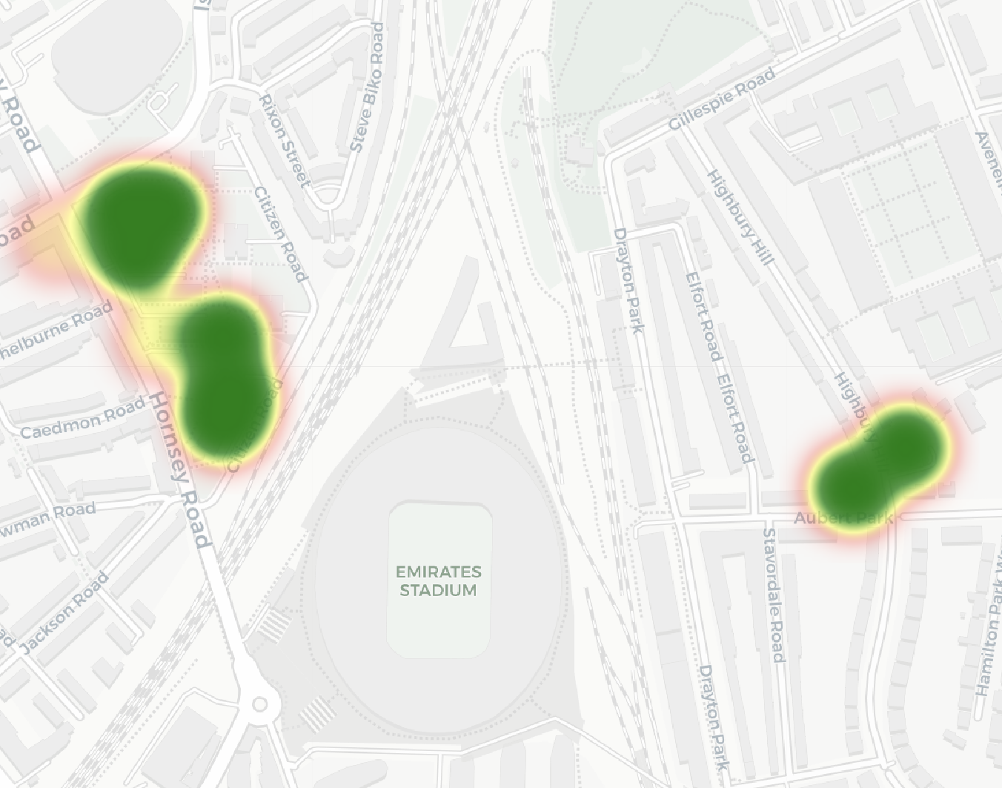
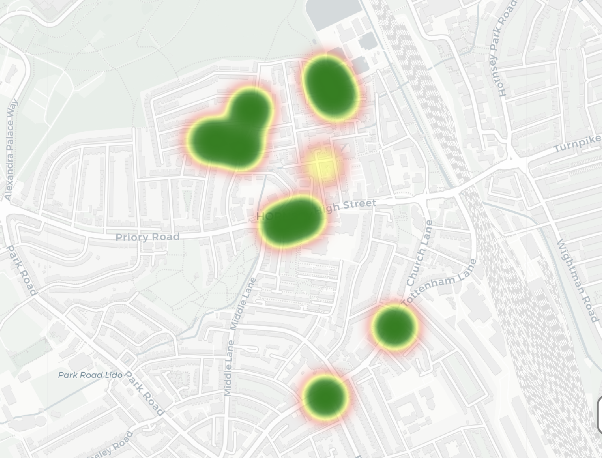

Haringey
Islington

